Assignment-2
1.Git Setup https://confluence.atlassian.com/bitbucket/set-up-git-744723531.html.
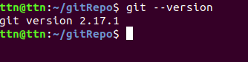
2.Initialize a Git Repository.
3.Add files to the repository
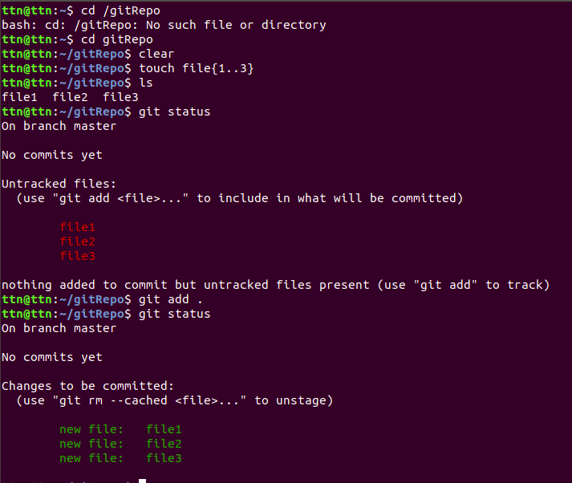

4.Unstage 1 file.
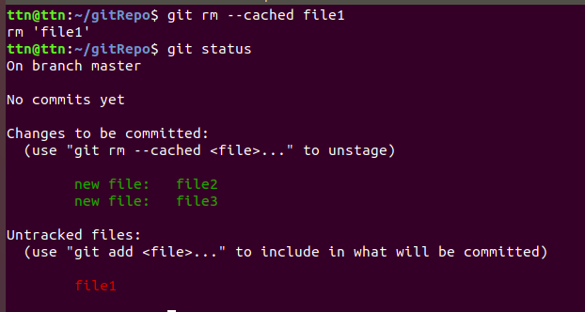
5.Commit the file.
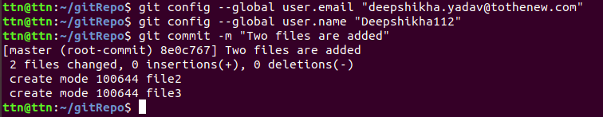
6.Add a remote.
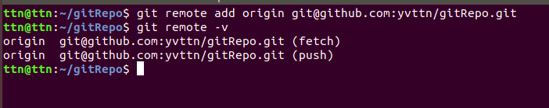
7.Undo changes to a particular file.
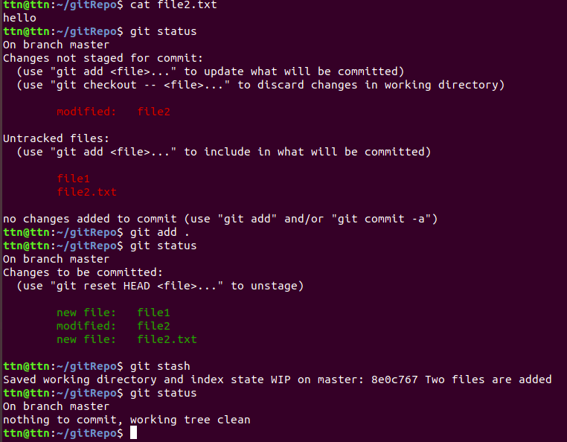

8.Push changes to Github.

9.Clone the repository.

11.Check differences between a file and its staged version.

12.Ignore a few files to be checked in.
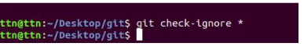
13.Create a new branch.
git branch newbranch
git branch -av
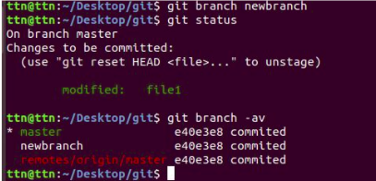
14.Diverge them with commits.

15.Edit the same file at the same line on both branches and commit.

16.Try merging and resolve merge conflicts.
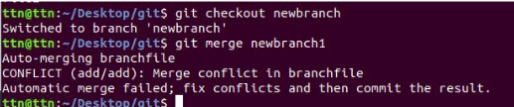
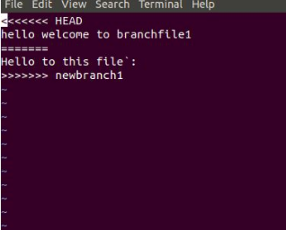
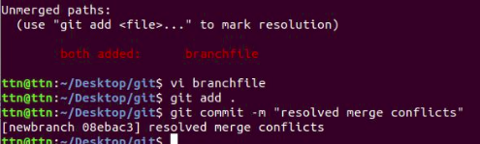
17.Stash the changes and pop them.
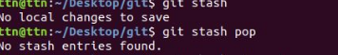
18.Add the following code to your .bashrc file : color_prompt="yes"
parse_git_branch() {
git branch 2> /dev/null | sed -e '/^[^*]/d' -e 's/* \(.*\)/(\1)/'
}
if [ "$color_prompt" = yes ]; then
PS1='\u@\h\[\033[00m\]:\[\033[01;34m\]\W\[\033[01;31m\] $(parse_git_branch)\[\033[00m\]\$ '
else
PS1='\u@\h:\W $(parse_git_branch)\$ '
fi
unset color_prompt force_color_prompt

